NAME: S. DHARANI
REG NO: 192472364
COURSE CODE: DSA0401
NUMPY / PANDAS ANALYSIS – QUESTIONS AND ANSWERS
QUESTION 8: TOP FIVE BEST-SELLING PRODUCTS
AIM:
To identify the five products with the highest total sales quantity using Pandas.
ALGORITHM:
1. Import Pandas.
2. Create a sales DataFrame.
3. Group records by product.
4. Add the quantities for each product.
5. Sort in descending order and display the first five.
CODE:
import pandas as pd
data = {
"Product": ["Pen", "Book", "Pen", "Bag", "Book", "Bottle", "Pencil"],
"Quantity": [20, 15, 10, 8, 12, 18, 25]
}
df = pd.DataFrame(data)
top5 = df.groupby("Product")["Quantity"].sum().sort_values(ascending=False).head(5)
print(top5)

INPUT:
Product sales records with product names and quantities.
OUTPUT:
Pencil 25
Pen 30
Book 27
Bottle 18
Bag 8
Top five are displayed in descending order.
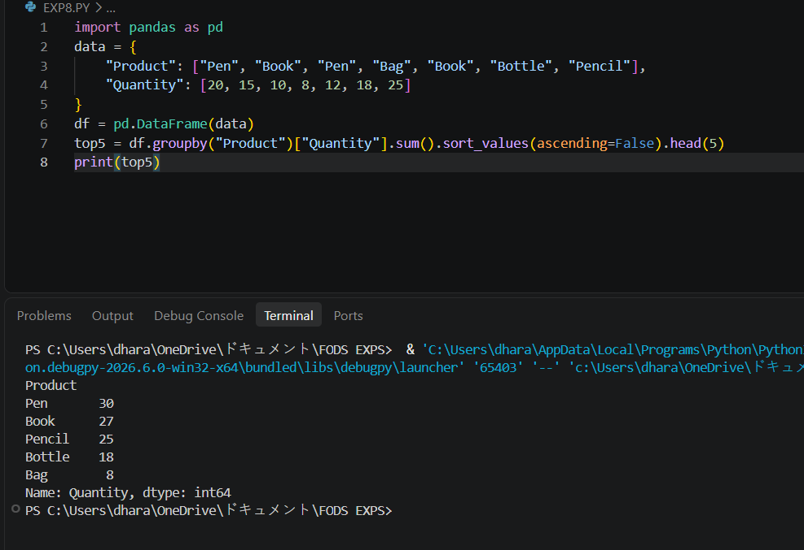
RESULT:
The five products with the highest total quantities were identified successfully.

